CRUD program

CRUD (Create, Read, Update & Delete) is a program that is like in data base system that enables the user to add details of a student, costumer, employee, …etc., depending on the necessity of it.

I will start with showing the main () body of the program partially.

This photo shows the main body of the program, that how I started some welcoming sentences and then to tell the user to start registering the student’s name, age and major sequentially by saving them into 1D array.

After the first registration, the program will get into a while loop that the user can leave it by pressing 0, then the question will be about whether the user wants to create, read, update or delete users by getting into a switch statement.

In case 1, which is the create, the program summons the three functions of name, age and major which are identified below the main.

In case 2, which is the read, the program asks which student would you like to read, and user enters the number, and then it goes to an if statement, if the number is already in the deletion array, which is being filled by case 4 as we’ll see, the program will print that it is deleted, else, it will show the information that we need about that registration.

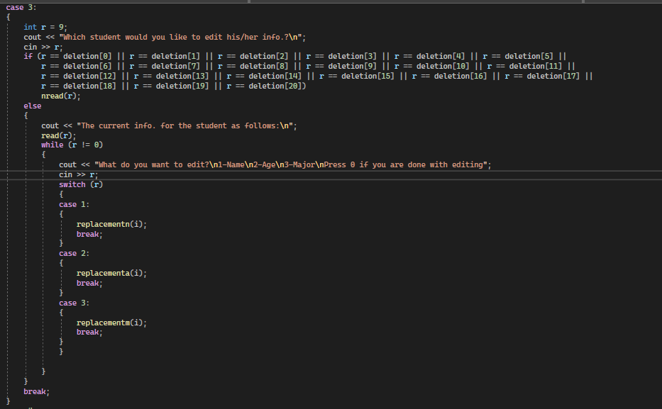

Case 3, which is the update case, asks about which student would you like to update his or her information, then the user enters a number, now, if the number of registration is deleted, it will tell the user that this number is deleted and you are not allowed anymore to update it and it will leave the case, else if it is not deleted, it will go into an internally while loop, and this loop includes a question about what would you like to update about the student’s information and pressing 0 to leave editing.

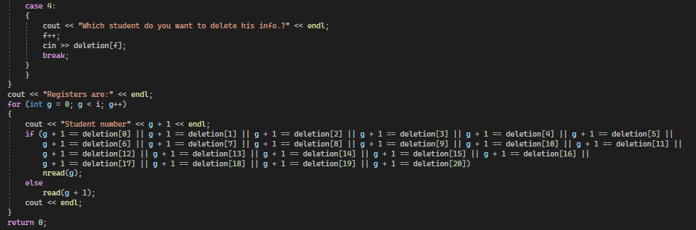

Case 4, which is the deleting case, starts by asking about the number of the student that you want to delete, after inserting the number, it will be stored in deletion array.

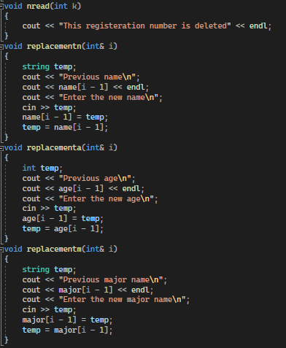

The nread() is an abbreviation of not read and I used it to express the deleted numbers.

Replacement n, a and m are used at update case to replace the previous names with the new names, ages and majors, and I used the temporary string to replace it with.

Then, after pressing 0 and leave the while loop and program, it will show the whole registers including the deleted.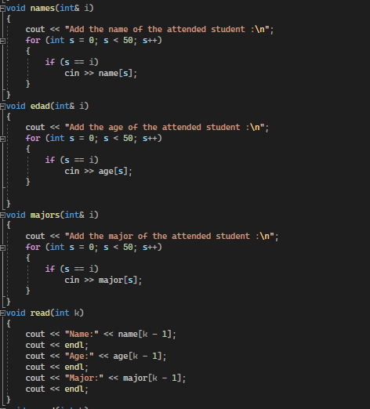

The photo shows the functions built for storing the names, ages and majors, and as we can see, the necessity of the if statement in each of them is to store it once at each incremental (i) for one user.

For the read function, it will read the number chosen by passing this value to it.